Gáirdín na n-Óg- 2014
Gaelscoil Inse Chór

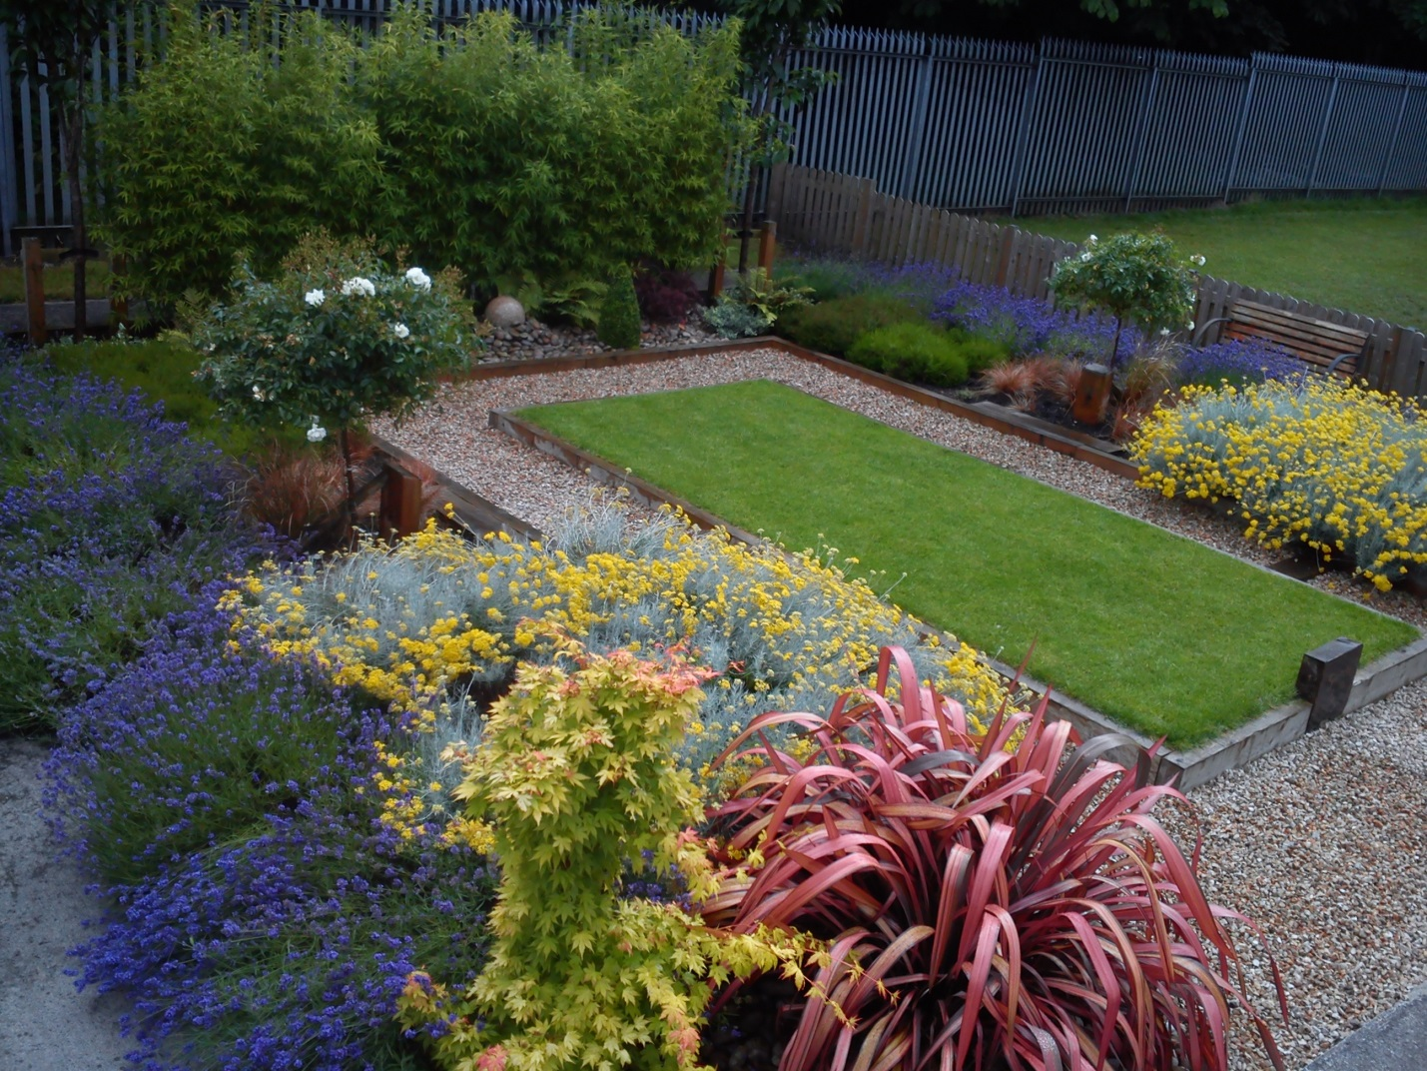
Tá cuireadh roimh comhphobal na scoile cuairt a thabhairt ar ár ngáirdín am ar bith. Tógaigí nóiméad ciúnas ann. D’osclaíomar ár ngáirdín i 2012 in ónóir iad siúd a bhí lárnach sa scoil idir pháistí, tuismitheoirí, múinteoirí agus cairde a chailleadh thar na blianta.
You are invited to visit our garden anytime. Please take a moment silence there. We opened our garden in 2012 in honour of all who were central to our school between children, parents, teachers and friend who have passed over time.

